Holiday Homework

Class 12 - Accountancy

1. On March 31, 2017 after the close of accounts, the capitals of Mountain, Hill, and Rock stood in the books of the firm at ₹ 4,00,000, ₹ 3,00,000 and ₹ 2,00,000, respectively. Subsequently, it was discovered that the interest on capital @ 10% p.a. had been omitted. The profit for the year amounted to ₹ 1,50,000 and the partner’s drawings had been Mountain: ₹ 20,000, Hill ₹ 15,000 and Rock ₹ 10,000. Calculate interest on capital.
2. Following is the extract of the Balance Sheet of Yogesh and Ram as on March 31st , 2025:

Balance Sheet

as at 31st March, 2025

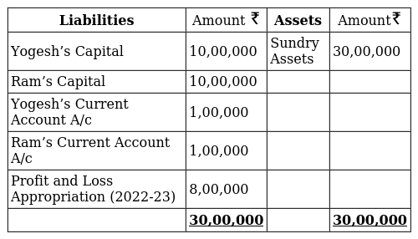

During the year Ram’s drawings were ₹ 30,000. Profits during year ended 31st March, 2025 is ₹10,00,000. Calculate interest on capital @ 5% p.a for the year ending March 31st , 2025.

1. Yogesh and Mukesh are partners with capitals of ₹ 3,00,000 each as on 31st March, 2025. Yogesh had withdrawn ₹ 50,000 against capital on 1st October, 2024 and ₹ 1,00,000 drawings against profit. Mukesh also had drawings of ₹ 1,00,000.

Interest on capital is to be allowed @ 10% p.a.

Net profit for the year was ₹ 2,00,000, which is yet to be distributed.

Pass the Journal entries for interest on capital and distribution of profit.

1. P and Q were partners in a firm sharing profits in 3: 1 ratio. Their respective fixed capitals were₹ 10,00,000 and ₹ 6,00,000. The partnership deed provided interest on capital @ 12% p.a. The partnership deed further provided that interest on capital will be allowed fully even if it will result into a loss to the firm. The net profit of the firm for the year ended 31st March, 2025 was ₹ 1,50,000.

Pass necessary journal entries in the books of the firm allowing interest on capital and division of profit/loss among the partners.

1. Ram, Ravi and Preeti are partners in a firm. On 1st April, 2024, the balance in their Capital Accounts stood at ₹ 14,00,000, ₹ 6,00,000 and ₹ 4,00,000 respectively. They shared profits in the proportion of 7 : 3 : 2 respectively. Partners are entitled to interest on capital @ 6% per annum and salary to Ravi @ ₹ 50,000 p.a. and a commission of ₹ 3,000 per month to Preeti as per the provisions of the Partnership Deed. Ravi’s share of profit (excluding interest on capital) is guaranteed at not less than ₹ 1,70,000 p.a. Preeti’s share of profit (including interest on capital but excluding commission) is guaranteed at not less than ₹ 1,50,000 p.a. Any deficiency arising on that account shall be met by Ram. The profit of the firm for the year ended 31st March, 2025 amounted to ₹ 9,50,000.

Prepare’Profit and Loss Appropriation Account for the year ended 31 st March, 2025.

1. A, B and C are partners in a firm. They have omitted interest on capital @ 10% p.a. for three years ended 31st March, 2023. Their fixed capitals on which interest was to be calculated throughout were:

A: 1,00,000; B: 80,000 & C: 70,000.

Give the necessary adjusting journal entry with working notes.

1. The partners of a firm distributed the profits for the year ended 31st March, 2025, Rs 1,20,000 in the ratio of 2 : 2 : 1 without providing for the following adjustments :

A and B were entitled to a salary of Rs 1,500 per quarter.

C was entitled to a commission of Rs 6,000.

A and C had guaranteed a minimum profit of Rs 48,000 p.a. to B.

Profits were to be shared in the ratio of 4 : 3 : 2.

Pass necessary journal entry for the above adjustments in the books of the firms.